Name(s): ___________________________________________

**Nonfiction/Argument Writing**

1. Identify the claim in green, the counterclaim in red, and the reasons in purple for each of the following statements. Also, highlight in yellow the words that help to signal a stance and let you know that you are looking at a sentence structured to include the claim/counterclaim.

* To be safe, teens really do need to practice driving for at least six months after turning 16 before they can get a license despite the fact that some argue the unfairness of delaying driving privileges.
* However expensive elective courses in the arts and music may be, they must be kept to give students a creative outlet during their school day.
* So that high school students are more alert both driving to school and learning in class, they need a later school starting time even if bus scheduling and childcare for younger siblings are then more complicated.

1. Write a claim statement (**one** concise sentence) about the following issue that includes and codes all of the items above (claim, counterclaim, reasons, signal words): Should Central Bucks elementary schools outlaw homework?
2. Look at the following editorial cartoon and answer the questions below it.

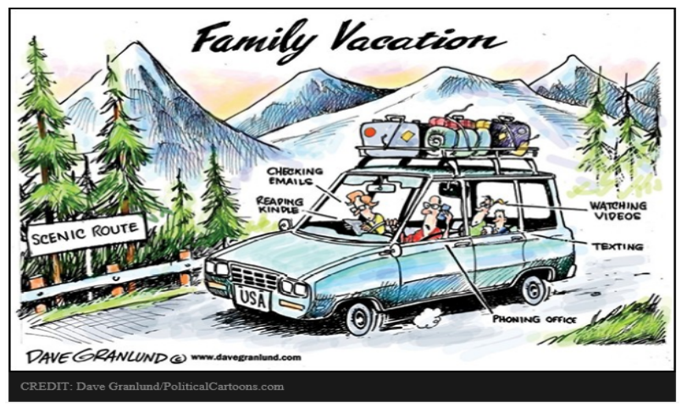

* What is happening in the cartoon?
* What is ironic? (HINT: Is there a conflict between being connected and the point of family vacation?)
* According to the cartoon and according to your own thoughts about the issue, what are the benefits/downsides of being connected? What is the impact on society of being connected?

1. Read the following Yes/No articles exploring the question “Are We Too Wired?” For **each** article, highlight/color code the following content: the claim (green), the reasons/the supporting facts (blue).

**Are We Too Wired? – Yes:**

About a year and a half ago, I attended a meeting in Geneva, Switzerland, that gathered 450 “changemakers” to tackle some of the world’s most pressing challenges. I thought the participants would emerge with new relationships and perspectives on complex issues such as poverty and climate change. Instead, participants spent the meeting glued to their phones, taking selfies and sharing on Facebook.

This experience is typical of a shift in values taking place in our society. Increasingly, we’re spending time engaged in activities less for their own intrinsic value and more for how we will look to others if we’re seen on social media doing them.

I think something important is lost in the process of sharing so much of ourselves online. Social media “likes” and new followers provide us with public approval, but this need for constant sharing of ourselves – and the immediate gratification that comes with it – diminishes the meaning and significance of the things we share. Some parts of our lives are worth keeping private.

Many of the relationships we form online are largely superficial, and the constant online sharing has psychological consequences. A handful of studies, including one recently conducted by the University of Michigan, suggest that increased Facebook usage contributes to anxiety and even depression. We are constantly seeing what others are doing and paying attention to their lives as they unfold in real time. That deepens our anxiety and uncertainty about whether we are leading lives that fulfill our own potential.

Lost in the online sharing and advice-gathering is the fundamental ability to reflect on questions by ourselves, taking as much time as we need to come to our own decisions. In short, because of our growing dependence on constant digital connectedness, we have become afraid of spending time alone.

-Emerson Csorba (Fellow, Canada’s Public Policy Forum)

**Are We Too Wired? – No:**

Humans are social creatures, so we naturally seek out opportunities to connect with others. The internet is particularly effective in helping us do that.

The positive influence of the internet in terms of human connection is evident in many areas. Music, sports, and culture spread easily across the globe, providing powerful links across international borders. Twitter allows me to share my opinion on the issues I care about – much as I would at the dining room table. The key difference is that I’m now able to tap into a global community, not just a local one.

The internet also enables people to easily engage with causes they care about – and make an impact on the world. Consider the ALS ice bucket challenge. Thanks to 2.2 million Twitter mentions and 2.4 million Facebook videos, it swept across the nation in the summer of 2015. In the challenge, people dumped a bucket of ice water over themselves to raise awareness about the debilitating disease ALS, also known as Lou Gehrig’s disease. The ice bucket challenge raised more than $115 million that ended up leading to a major scientific breakthrough.

When I first began researching social media in 2004, it was assumed that people who chose to interact online did so because real-world social opportunities were closed off to them. But studying teenagers who used chat rooms, I discovered a generation of digital natives who were as socially adjusted as their peers.

In fact, many studies have shown that people who connect with others online are less likely to be socially isolated than their peers who don’t. One kind of digital interaction, online dating, is now the second-most-common way to meet someone. And couples who have met online have marriages that are just as strong as those who met in real life.

There are aspects of social media that cause more harm than good. But overall, the deeper connections that take place online make it easier than ever to engage with the world and change it for the better.

-Noa Gafni Slaney (Founder and Chief Executive, Impact Squared)

1. Practice your argument-writing skills! Your argument paragraph must include the following:

* Your claim statement as the topic sentence of your paragraph – this sentence must include an acknowledgement of the counterclaim and preview at least two reasons to support your claim
* Discussion of at least two reasons to support your claim
* This must include at least 1 directly-quoted snippet—just a piece—of evidence rather than a whole, quoted sentence. Just a piece can be embedded into a sentence that helps to explain your stance.

Ex:  When one tech writer claims that Google “…is encouraging us to think superficially,” he is expressing his skepticism about the internet’s easy, fast accessibility to be truly beneficial (Carr 22).

* Transition (use signal words) to the counterclaim and include at least 1 directly-quoted snippet/piece of evidence to explain what the opposition thinks
* Refutation of the opposition—why is that oppositional point invalid/illogical/not as strong as your point?
* Closing sentence firmly reviewing the point of your paragraph/your stance.

1. Type your argument paragraph below and color-code it according the following directions.

* claim statement
* 2 reasons/supporting evidence
* Signal word(s) to transition to the counterclaim
* counterclaim reason/ supporting evidence
* refutation of counterclaim
* closing sentence

**PARAGRAPH--Type it here and do color-coding. Then, don’t miss final steps.**

1. FINAL STEPS: Save this document and attach it in an email to me and your partner(s). ***ALSO***, copy your argument paragraph and paste it directly into the email so it’s easier for me to provide feedback.